Safe Places Isle of Wight
– Premises Registration Form
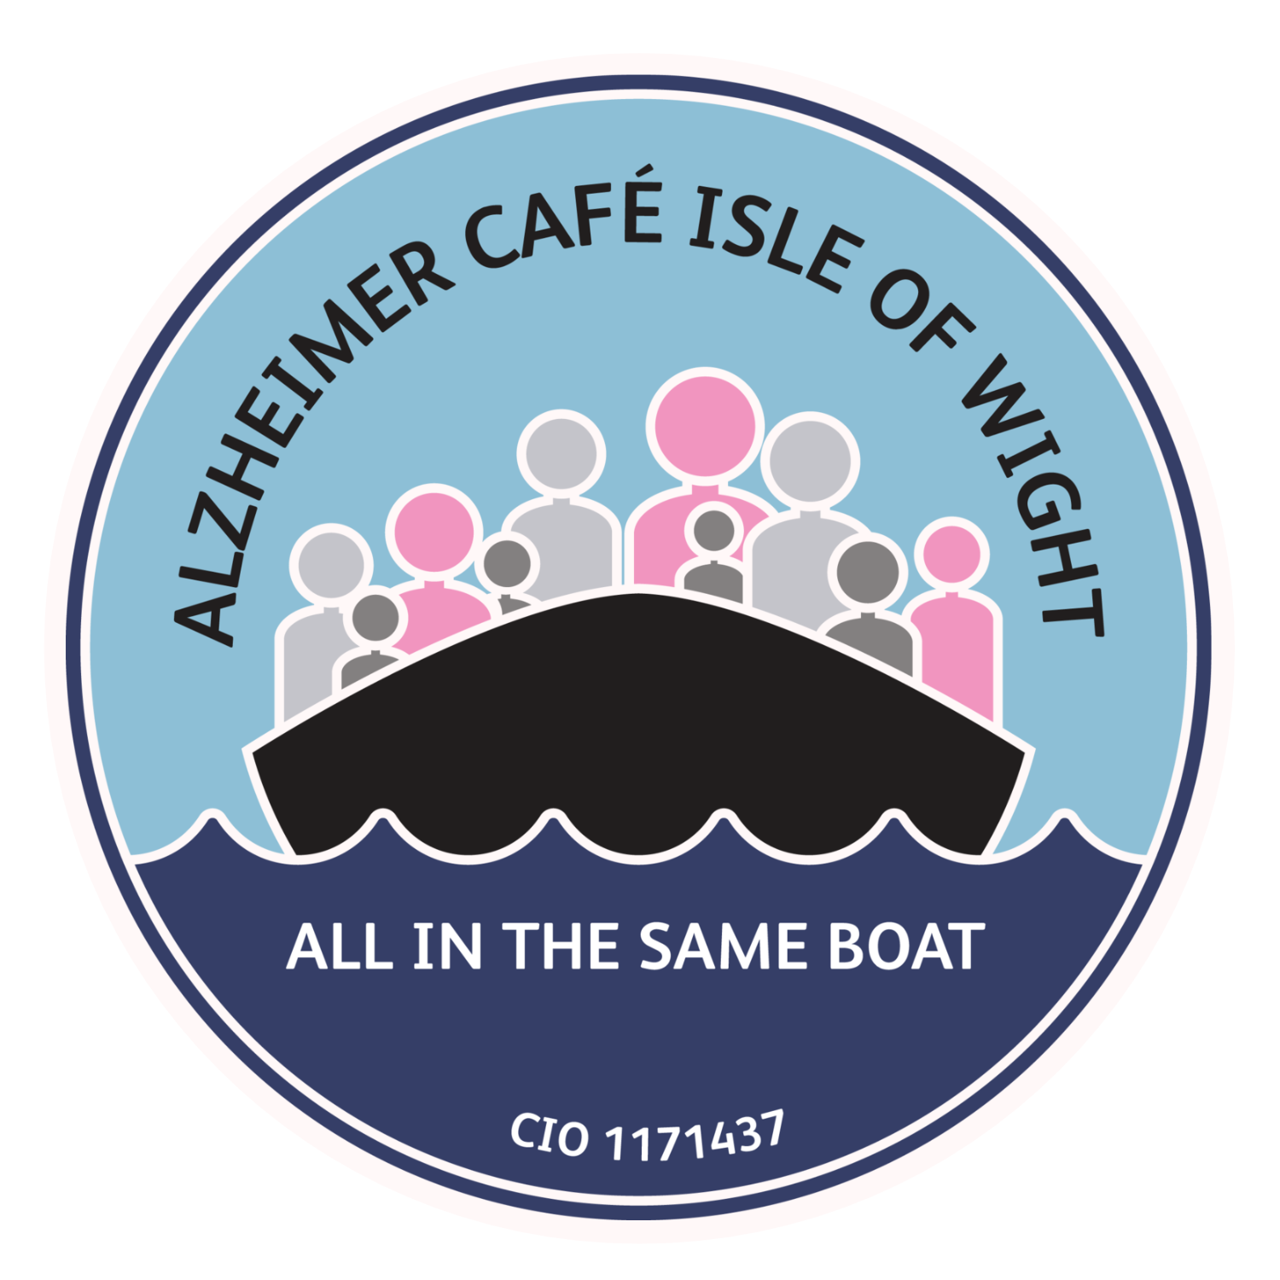
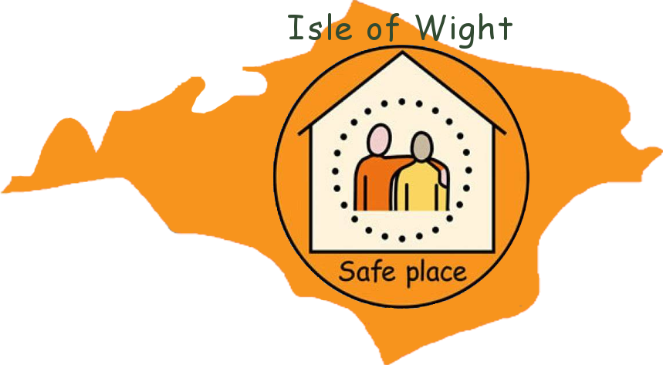



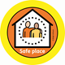

A quick thank you from us!
Thank you for volunteering your location to be a Safe Place on the Isle of Wight.
Our volunteer locations are the life force that makes Safe Places IOW happen and for that, we are eternally grateful for your help and time.
In becoming a Safe Place, you’re not only supporting your local community (even more so than you already do), but you’re also becoming part of the wider national Safe Places family.
If you want to find out more about our local story, you can find us on our website:
www.Safeplacesiow.com
On the national website:
www.safeplaces.org.uk
As well as on our socials:
www.facebook.com/safeplacesiow
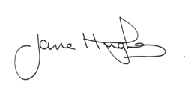
If you have any questions, please feel free to send a message our way.

Jane Hughes
Safe Places IOW Coordinator
07979 503968

Safe Place Provider Premises Registration Form
Your Organisation
Name:
Department:
Organisation Contact Details
Name and Position:
Main Phone | Mobile:
Email:
Website:
Postal Address:
Safe Place Venue Details (if multiple locations, please fill out additional registration forms):
Address of venue to be registered as a Safe Place (indicate if as above):
Contact Name:
Main Phone | Mobile:
Email:


Learning requirements
We can provide you and your staff with support to assist you in being a Safe Place. For example, we can provide disability awareness, dementia and mental health awareness, safeguarding awareness etc. Look on our website for awareness video clips and useful information guides. If you would like any learning resources, please let us know.
Please tick here if you would like to discuss your learning needs with our Safe Place Co-ordinator: ☐
Publicity:
We always raise awareness of the Safe Places Scheme through publicity, presentations, newsletters and social media. Please indicate below whether you agree to your organisations name and/or logo being included for this purpose.

If you are happy for your organisations logo to be used, please provide a Jpeg version by email to the address below.
Yes, please include our organisations name ☐ |  | No, please do not include our organisations name ☐
Yes, please include this organisations logo ☐ |  | No, please do not include our organisations logo ☐
Returning This Form:
Please return your completed form to:
Jane Hughes, Safe Places IOW Coordinator
makingconnectionsiow@outlook.com
For Office Use :
Completed form received | Organisations logo received |  | Date window stickers/badges issued
☐ | ☐ |  | ☐

Terms and Conditions of the voluntary Safe Places Scheme:

To become a Safe Place there are some essential basic points we need to agree on:
- you must be open to the public and have public liability insurance
- you must display the safe places sticker in your premises so that it is easily visible to the public
- advise us of any access issues for people with disabilities so we can point this out on our locations map. For example, steps into your location, doors not wide enough for access to a person using a wheelchair

As a minimum you agree to:
- provide a safe and supportive environment
- contact the appropriate emergency services immediately if the vulnerable person has been a victim of crime or needs medical assistance
- contact one of the people named on the back of the Safe Places Card (if they have one) where necessary
- allow the person to speak to the named person, if desired
- allow the person to wait on the premises until the named person (or police / ambulance) arrives or until they feel safe to leave
- keep your staff familiarised with the scheme so that they know what to do if a vulnerable person requires support
- notify the Safe Place Scheme Coordinator If you wish to withdraw from the scheme.

